ScreenShots

Server Side:-

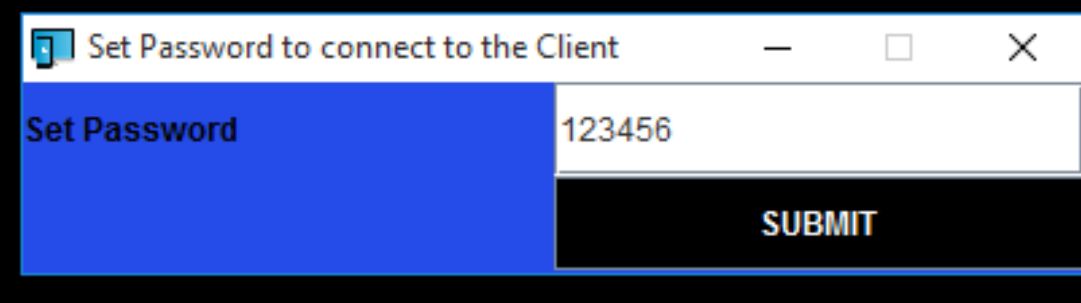

Client Side:-

For ip address
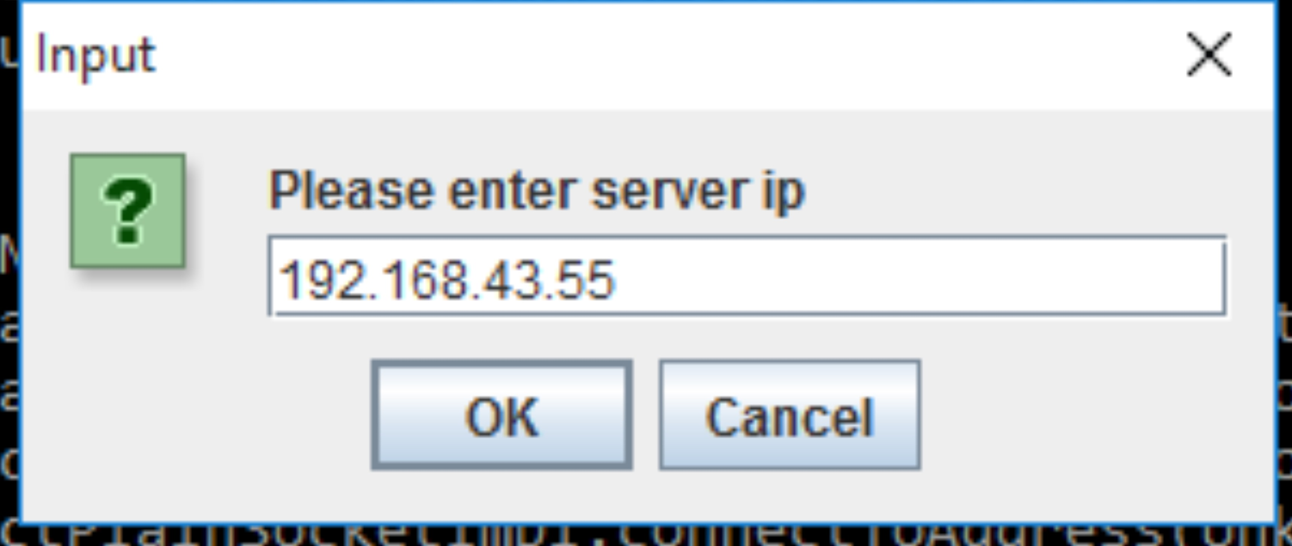

For password
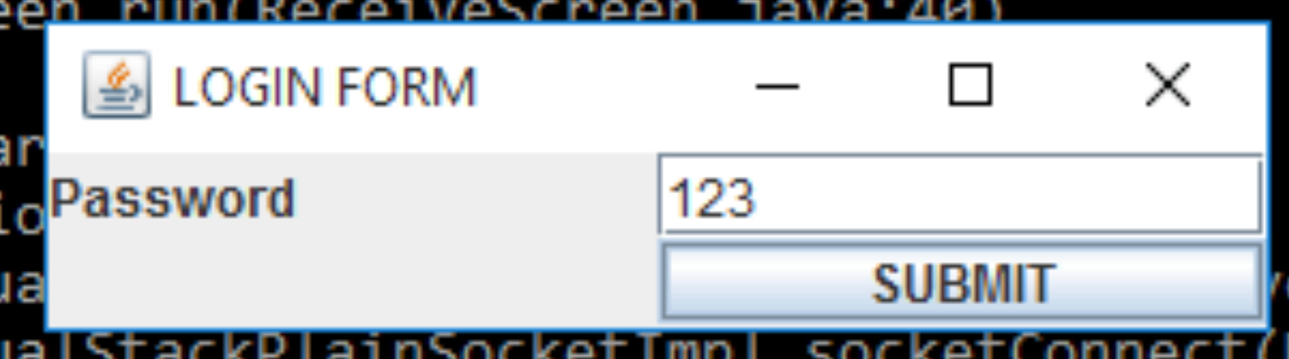

Remote Desktop Screen

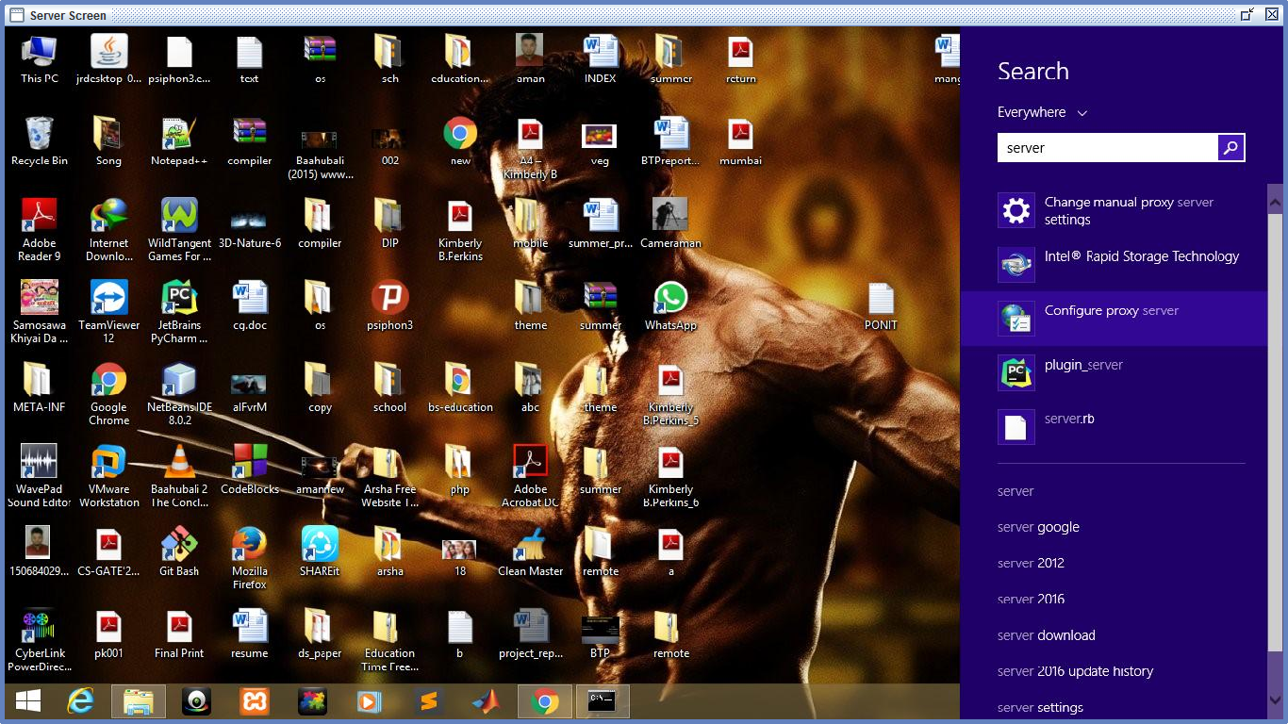

Conclusion

Till now we have developed backend programs in two modules first one is server which is used to allow access to the remote client and second module is client module which is used to Control Remote Computer.

Remaining Work

We have to encrypt the password set by the server which is not encrypted till now.
And we have to integrate the main GUI with the backend programs.

